Repair and Leasing Scheme Enquiry Form | 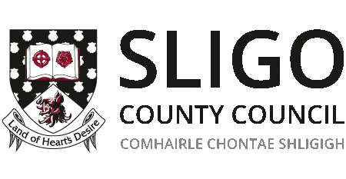
If you are interested in having your property repaired for leasing to Sligo County Council, please complete the form below.
1 – Contact Details
Name:
Address:
Telephone Number:
Email Address:
2 – Property Details
Property Address:
Property Eircode:
Type (Apt, Duplex, Semi-D, Bungalow etc.)
No. of Bedrooms
Floor Area (m²).
BER Rating
Copy of BER Certificate must be provided
3 - Property Title
Do you hold good, unencumbered, freehold title to the property?

If no, please provide details.
Is there a mortgage on the property?

If yes, have you enquired with your lender if they will consent to a lease arrangement?
Was the property previously a local authority property?

If yes, please give details of how you acquired the property
Is the property vacant?

If yes, for what period has it been vacant
Vacancy for a minimum of 1 year is a requirement of the Scheme
What are the circumstances of the vacancy?

Date the property would be available from

Please provide any other supporting documentation that you consider relevant i.e. photographs, copies of title documents, confirmation of lending institution etc.

Please submit completed form together with all relevant documentation to:
Sligo County Council
Repair & Leasing
Housing Department
County Hall
Riverside
Sligo
Or email to: repairandleasing@sligococo.ie

Tel. (071) 9111808 / (071) 9111221

